Analysis and Design Document

Version 4.1
Date 11/30/2014

Restaurant Automation System
Object Oriented Software Engineering
SE 6329

Aneri Shah
Danny Sundaresan
Malika Pahva
Siddharth Shah
Vidhi Gavadia

Version | Date | Description | Author
1.0 | 10/27/2014 | Designed Use case and Domain Model | Aneri Shah, Danny Sundaresan, Malika Pahva, Siddharth Shah, Vidhi Gavadia
2.0 | 11/03/2014 | Updated Use case and Domain Model. Compiled use case descriptions | Aneri Shah, Danny Sundaresan, Malika Pahva, Siddharth Shah, Vidhi Gavadia
3.0 | 11/10/2014 | Updated use case, use case descriptions and domain model. Compiled system sequence diagram, operational contract and architectural diagrams. | Aneri Shah, Danny Sundaresan, Malika Pahva, Siddharth Shah, Vidhi Gavadia
4.0 | 11/19/2014 | Updated use case, use case descriptions, system sequence diagram and operational contract.  Added Use case realization and Design class diagrams. | Aneri Shah, Danny Sundaresan, Malika Pahva, Siddharth Shah, Vidhi Gavadia
4.1 | 11/30/2014 | Updated use case, use case descriptions, system sequence diagram, operational contract, Use case realization and Design class diagrams. | Aneri Shah, Danny Sundaresan, Malika Pahva, Siddharth Shah, Vidhi Gavadia

Revision History

Table of Contents

- Use Case Diagram 4

- Prioritized List of Use Cases 8

- Use Case Description 11

- Domain Model 20

- System Sequence Diagram 22

- Operation Contracts 27

- Use Case Realization 31

- Design Class Diagram 34

- High-Level Architecture Diagram 37

1. Use Case Diagrams
Version 4.1
11/30/14

Restaurant Automation System

Version | Date | Description | Author
1.0 | 10/27/2014 | Designed Use case | Aneri Shah, Danny Sundaresan, Malika Pahva, Siddharth Shah, Vidhi Gavadia
2.0 | 11/03/2014 | Updated Use cases | Aneri Shah, Danny Sundaresan, Malika Pahva, Siddharth Shah, Vidhi Gavadia
3.0 | 11/10/2014 | Updated Use cases | Aneri Shah, Danny Sundaresan, Malika Pahva, Siddharth Shah, Vidhi Gavadia
4.0 | 11/19/2014 | Updated Use cases | Aneri Shah, Danny Sundaresan, Malika Pahva, Siddharth Shah, Vidhi Gavadia
4.1 | 11/30/2014 | Updated Use cases | Aneri Shah, Danny Sundaresan, Malika Pahva, Siddharth Shah, Vidhi Gavadia

Revision History

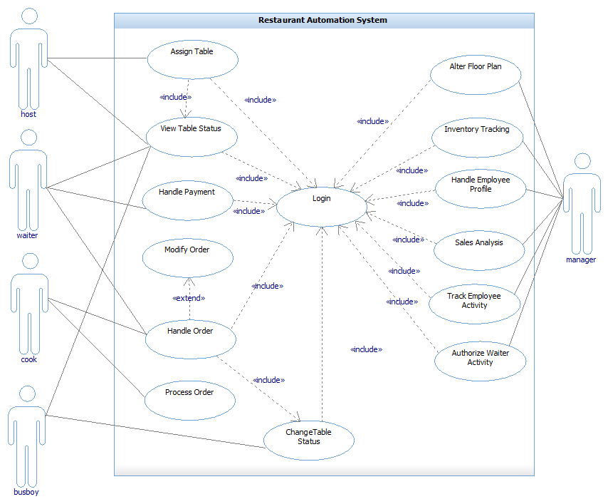
Use Case Diagram

Description
- Assign Table: The host will be able to assign a table to a waiter once he has assigned the same to a patron.
- View Table Status: The host, waiter and bus boy would be able to see the status of each table with the following color code. Red mean dirty, green is open and yellow is occupied.
- Change Table Status: The host would be able to assign tables and change their status from green to yellow. The waiter would be able to change the table status from yellow to red and finally the bus boy would be able to change status from red to green.
- Handle Order: The waiter would be able to browse the menu of the items available and place order for each table based on the patrons choice. The cook would be able to view these orders.
- Handle Payment: The waiter handles the payment made by the patron for the placed order.
- Process Order: The cook would be able to process the order and notify the appropriate waiter once the food is ready.
- Modify order: Once the waiter has placed the order, he/she can modify it by adding or removing items if the patron requests for it.
- Alter Floor Plan: The manager would be able to change the position of the tables in the restaurant.
- Inventory Tracking : The manager would be able to track the inventory of the restaurant
- Handle Employee Profile: The manager would be able to create a new profile when a new employee joins the restaurant and can modify their status anytime he wants.
- Sales Analysis: The manager would be able to view the daily /monthly / yearly sales of the restaurant.
- Track Employee Activity: The manager can track how long the cook takes to prepare an order, then he can also track the efficiency of a waiter based on patrons rating and finally he can also track how soon the bus boy cleans the table.
- Authorize Waiter Activity: The manager can restrict the activity of the waiter in the system.

2. Prioritized List of Use Cases
Version 4.1
11/30/14

Restaurant Automation System

Version | Date | Description | Author
1.0 | 10/27/2014 | Prioritized use cases | Aneri Shah, Danny Sundaresan, Malika Pahva, Siddharth Shah, Vidhi Gavadia
2.0 | 11/03/2014 | Updated prioritized use cases | Aneri Shah, Danny Sundaresan, Malika Pahva, Siddharth Shah, Vidhi Gavadia
3.0 | 11/10/2014 | Updated prioritized use cases | Aneri Shah, Danny Sundaresan, Malika Pahva, Siddharth Shah, Vidhi Gavadia
4.0 | 11/19/2014 | Updated prioritized use cases | Aneri Shah, Danny Sundaresan, Malika Pahva, Siddharth Shah, Vidhi Gavadia
4.1 | 11/30/2014 | Updated prioritized use cases | Aneri Shah, Danny Sundaresan, Malika Pahva, Siddharth Shah, Vidhi Gavadia

Revision History

Priority List
- Handle Order
- Process Order
- Assign Table
- Change Table Status
- Handle Payment
- View Table Status
- Inventory Tracking
- Alter Floor Plan
- Sales Analysis
- Track Employee Activity
- Handle Employee Profile
- Authorize Waiter Activity

Fully Dressed | Casual | Brief
- Handle Order | - Process Order | - Assign Table
 |  | - Change Table Status
 |  | - Handle Payment
 |  | - View Table Status
 |  | - Inventory Tracking
 |  | - Alter Floor Plan
 |  | - Sales Analysis
 |  | - Track Employee Activity
 |  | - Handle Employee Profile
 |  | - Authorize Waiter Activity

3. Use Case Description
Version 4.1
11/30/14

Restaurant Automation System

Version | Date | Description | Author
2.0 | 11/03/2014 | Use case description based on priority. | Aneri Shah, Danny Sundaresan, Malika Pahva, Siddharth Shah, Vidhi Gavadia
3.0 | 11/10/2014 | Updated fully dressed use case description | Aneri Shah, Danny Sundaresan, Malika Pahva, Siddharth Shah, Vidhi Gavadia
4.0 | 11/10/2014 | Updated fully dressed, casual and brief use case description | Aneri Shah, Danny Sundaresan, Malika Pahva, Siddharth Shah, Vidhi Gavadia

Revision History
Use Case Name | Login
ID | 1
Brief description | The restaurant staffs can log into the system.
Primary actors | Manager, Host, Waiter, Busboy
Second actors | None
Pre Conditions | The restaurant staff must have an account in the system.
Main flow | - The staff opens the system  - The staff enters the username and password via the keyboard in the respective fields provided.  - The system verifies the user.
Post conditions | - The restaurant staff is logged in to the system.  - The restaurant staff can access the assigned home page.
Non-Functional Requirements | - The login should happen within 5 seconds.  - Multiple users can be logged in at any given time.
Technology and Data Variation List | The restaurant staff can use his/her respective portable devices
Open Issues | - Will the account freeze if the wrong username and password is typed more than three times?

Use Case Name | Handle order
ID | 2
Brief description | The waiter handles the order placed by the patron.
Primary actors | Waiter
Second actors | Cook
Pre Conditions | The table must be occupied by the patron.
Main flow | - Include (Login).  - The system displays the list of tables assigned to the waiter.  - Include (Change Table Status).  - The patron specifies the items he would like to have.  - The waiter starts a new order.  - The waiter selects the “add item” option in the system.  - The system generates a list of categories available in the menu.  - The waiter selects the specific category under which he could find the specified item.  - The waiter adds the item to the order.  - The waiter repeats step 7 to 10 until all the items have been added to the order.  - The waiter places the order.  - The system adds the order to the order queue.  - The system notifies the cook that a new order is added to the queue. *a At any point, the waiter modifies the placed order as per the patron’s request.
Post Conditions | None
Non-Functional Requirements | The order queue should get updated in about 2 seconds once a new order is updated.
Technology and Data Variation List | The restaurant staff can use his/her respective portable devices.
Open Issues | - Can the waiter cancel the order once it has been placed?  - Can the waiter add specific comments from the patron about an item so that the cook can view them?

Use Case Name | Process Order
ID | 3
Brief description | The cook would be able to process the order and notify the appropriate waiter once the food is ready.
Primary actors | Cook
Second actors | None
Pre Conditions | Order is added to the order queue.
Main flow | - Include (Login).  - Includes (View order)  - The cook selects the first order in the order queue.  - The cook changes the order status to ready once the food items have been cooked.
Post Conditions | The system notifies the waiter that the order is ready.

Use Case Name | Assign table
ID | 4
Brief description | The host can assign un-occupied tables to patrons.
Primary actors | Host
Second actors | None

Use Case Name | Handle Payment
ID | 5
Brief description | The waiter handles the payment made by the patron for the placed order.
Primary actors | Waiter
Second actors | None

Use Case Name | Change Table Status
ID | 6
Brief description | The host, waiter, busboy can change the status of the table from free to occupied, occupied to dirty, dirty to free respectively.
Primary actors | Busboy, Waiter, Host
Second actors | None

Use Case Name | Inventory Tracking
ID | 7
Brief description | The manager keeps track of the inventory required for the restaurant.
Primary actors | Manager
Second actors | None

Use Case Name | Alter Floor Plan
ID | 8
Brief description | The manager changes the position of the tables in the restaurant and re- arranges them whenever new tables have been added to the floor plan.
Primary actors | Manager
Second actors | None

Use Case Name | Sales Analysis
ID | 9
Brief description | The manager views the daily /monthly / yearly sales of the restaurant.
Primary actors | Manager
Second actors | None

Use Case Name | Track Employee Activity
ID | 10
Brief description | The manager keeps track of how long the cook takes to prepare an order. He/she can also track the efficiency of a waiter as well as how soon the busboy can clean the table.
Primary actors | Manager
Second actors | None

Use Case Name | Handle Employee Profile
ID | 11
Brief description | The manager creates a new profile when a new employee joins the restaurant as well as modify the profile of other employees when needed.
Primary actors | Manager
Second actors | None

Use Case Name | Authorize Waiter Activity
ID | 12
Brief description | The manager restricts the activities of the waiters in the system.
Primary actors | Manager
Second actors | None

Use Case Name | Modify Order
ID | 13
Brief description Segment 1 | The waiter modifies the order if the patron requests for it.
Primary actors | Waiter
Second actors | None
Segment 1 Pre Conditions | The order is placed by the waiter.
Segment 1 flow | The waiter adds or removes items from the placed order.
Segment 1 Post Conditions | The order has been modified.

4. Domain Model
Version 4.1
11/30/14

Restaurant Automation System

Version | Date | Description | Author
1.0 | 10/27/2014 | Designed domain model | Aneri Shah, Danny Sundaresan, Malika Pahva, Siddharth Shah, Vidhi Gavadia
2.0 | 11/03/2014 | Updated domain model | Aneri Shah, Danny Sundaresan, Malika Pahva, Siddharth Shah, Vidhi Gavadia
3.0 | 11/10/2014 | Updated domain model based on operational contract | Aneri Shah, Danny Sundaresan, Malika Pahva, Siddharth Shah, Vidhi Gavadia
4.1 | 11/30/2014 | Updated domain model | Aneri Shah, Danny Sundaresan, Malika Pahva, Siddharth Shah, Vidhi Gavadia

Revision History

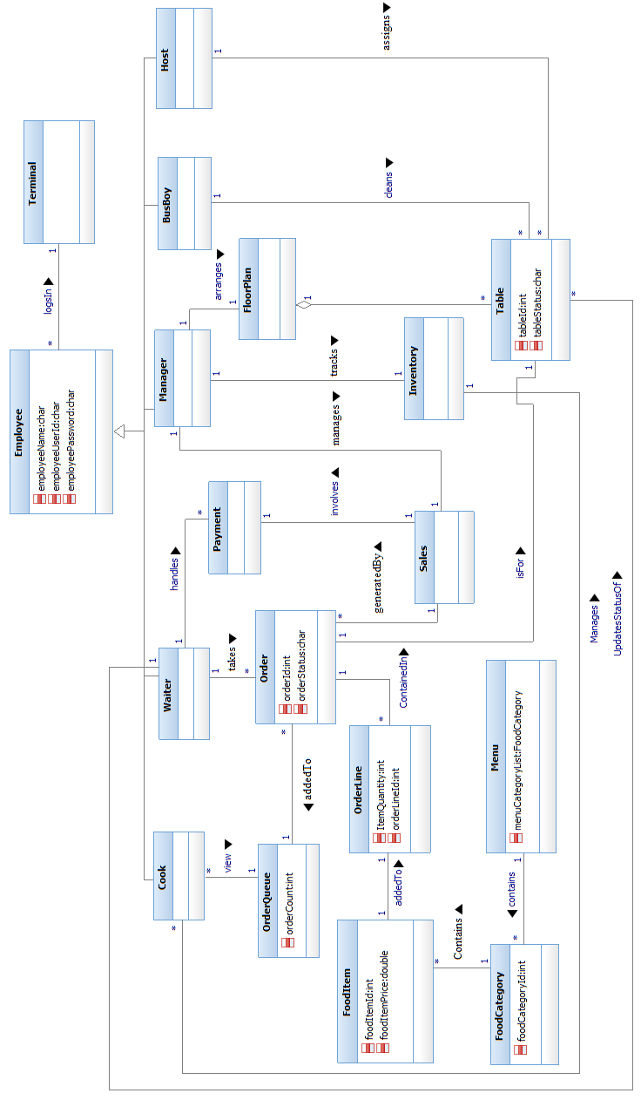
Domain Model

5. System Sequence Diagram
Version 4.1
11/30/14

Restaurant Automation System

Version | Date | Description | Author
3.0 | 11/10/2014 | Designed system sequence diagram | Aneri Shah, Danny Sundaresan, Malika Pahva, Siddharth Shah, Vidhi Gavadia
4.0 | 11/19/2014 | Updated system sequence diagram | Aneri Shah, Danny Sundaresan, Malika Pahva, Siddharth Shah, Vidhi Gavadia
4.1 | 11/30/2014 | Updated system sequence diagram | Aneri Shah, Danny Sundaresan, Malika Pahva, Siddharth Shah, Vidhi Gavadia

Revision History

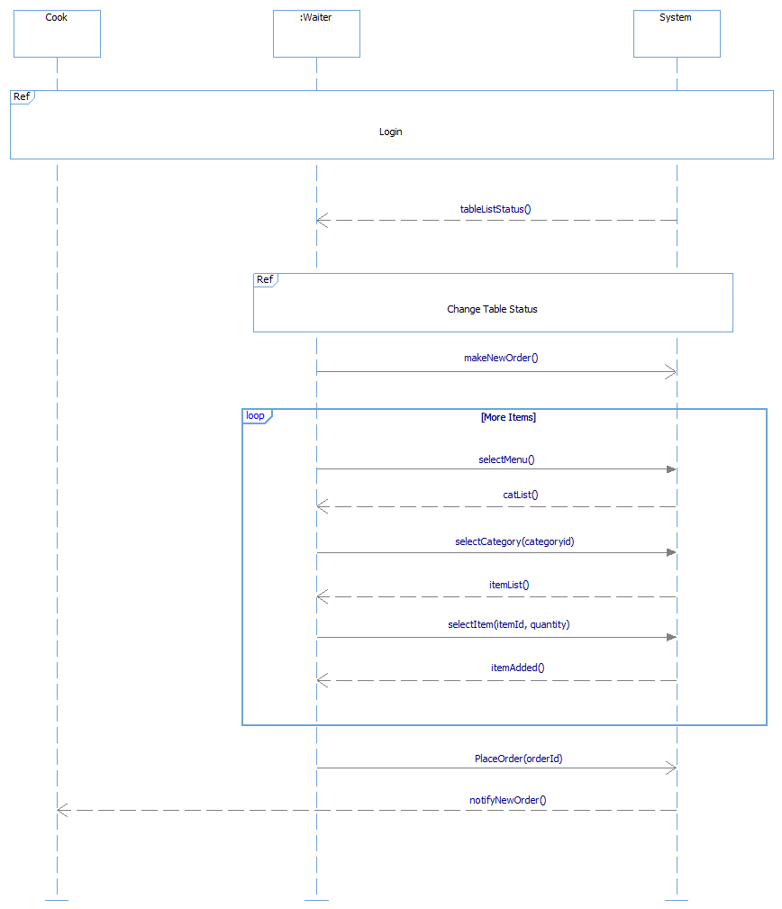
System Sequence Diagram

Reference Login

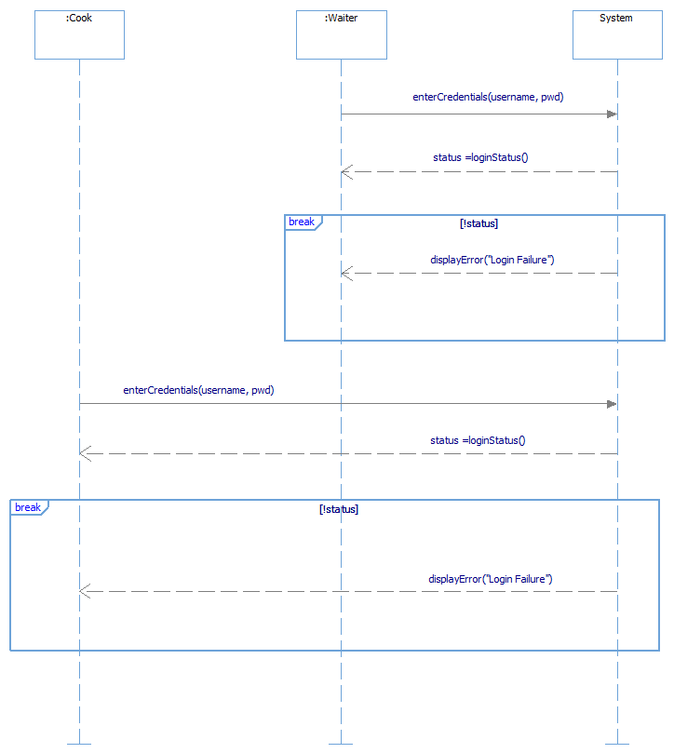

Reference Change Table Status
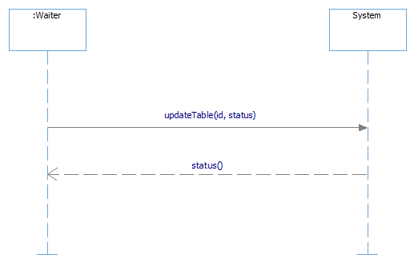

6. Operation Contracts
Version 4.0
11/19/14

Restaurant Automation System

Version | Date | Description | Author
3.0 | 11/10/2014 | Constructed operation contracts | Aneri Shah, Danny Sundaresan, Malika Pahva, Siddharth Shah, Vidhi Gavadia
4.0 | 11/19/2014 | Updated operation contracts | Aneri Shah, Danny Sundaresan, Malika Pahva, Siddharth Shah, Vidhi Gavadia

Revision History

Operation Contracts
Contract CO1: enterCredentials(username, pwd)
Cross Reference: Handle Order
Pre Conditions: None
Post Conditions: - e.employeeUserId becomes username and e.employeePassword becomes pwd.

Contract CO2: updateTable(tableId, status)
Cross Reference: Change Table Status
Pre Conditions: - A table instance t has already been created
- A waiter instance e was associated with the table instance t.
Post Conditions: - t.tableStatus becomes status based on tableId match.

Contract CO3: makeNewOrder()
Cross Reference: Handle Order
Pre Conditions: A waiter instance e was associated with the table instance t.
Post Conditions: - An order instance o is created.
- Attributes of o are initialized.
- o is associated with the table instance t.
- o is associated with the waiter instance e.

Contract CO4: selectMenu()
Cross Reference: Handle Order
Pre Conditions: - A menu instance m already exists.
Post Conditions: - FoodCategory instance c is associated with current menu.

Contract CO5: selectCategory(categoryid)
Cross Reference: Handle Order
Pre Conditions: - A menu instance m already exists.
- A FoodCategory instance c already exists.
- A FoodItem instance i has already been created.
- c has been associated with the menu.
Post Conditions: - The FoodCategory instance c is associated with the FoodItem instance i based on categoryid match.

Contract CO6: selectItem(itemId,quantity)
Cross Reference: Handle Order
Pre Conditions: - Order instance o has already been created.
Post Conditions: - A OrderLineItem instance oli is created.
- Attributes of oli are initialized.
- oli.quantity becomes quantity.
- Oli is associated with the current order o.
- oli is associated with the FoodItem based on the itemId match.

Contract CO7: placeOrder (id)
Cross Reference: Handle Order
Pre Conditions: - A waiter instance e was associated with the table instance t.
- A OrderQueue instance q already exists
Post Conditions: - The current order instance o, is associated with the OrderQueue instance q.

7. Use Case Realization
Version 4.1
11/30/14

Restaurant Automation System

Version | Date | Description | Author
4.0 | 11/19/2014 | Designed Use Case Realization Diagram | Aneri Shah, Danny Sundaresan, Malika Pahva, Siddharth Shah, Vidhi Gavadia
4.1 | 11/30/2014 | Updated Use Case Realization Diagram | Aneri Shah, Danny Sundaresan, Malika Pahva, Siddharth Shah, Vidhi Gavadia

Revision History

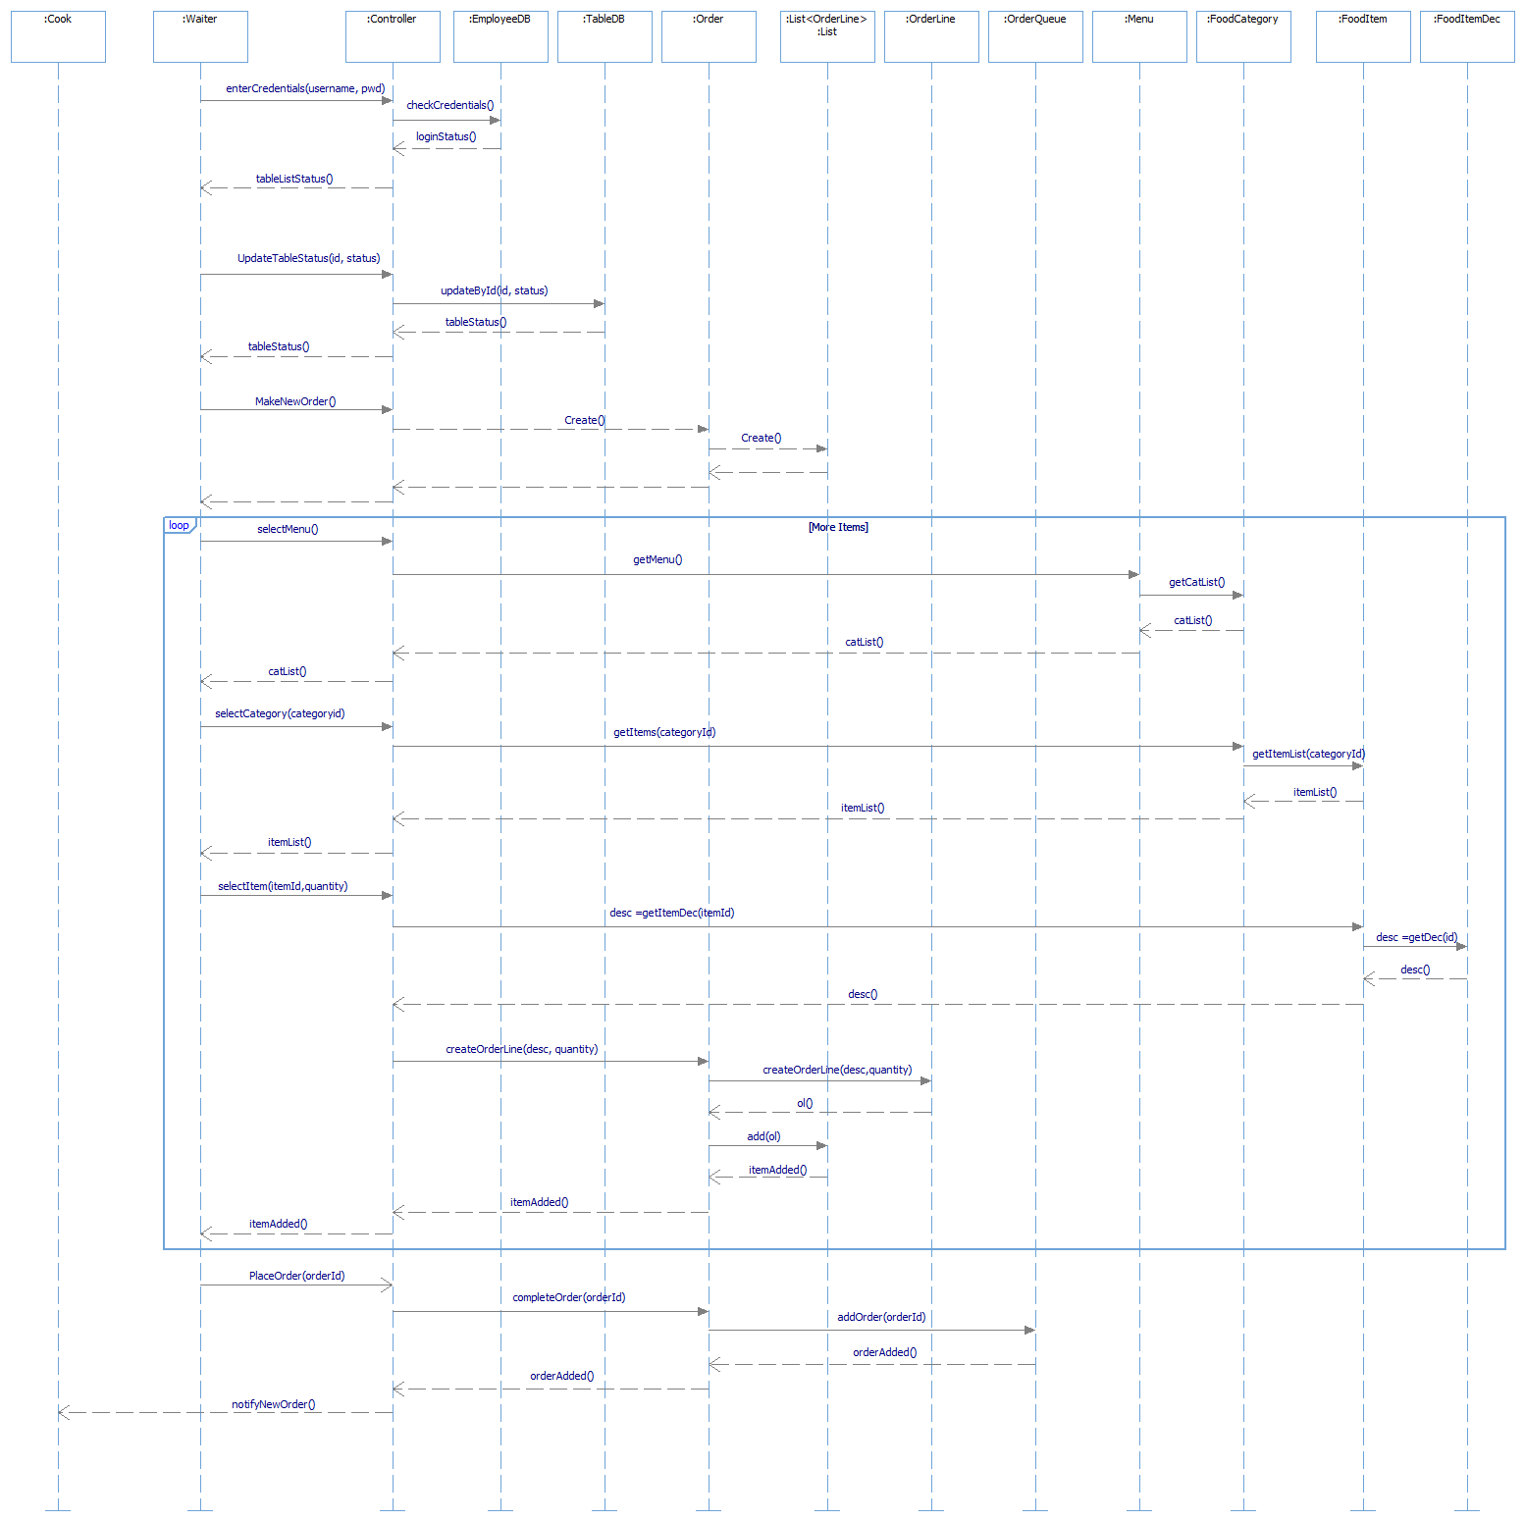
Use Case Realization

8. Design Class Diagram
Version 4.1
11/30/14

Restaurant Automation System

Version | Date | Description | Author
4.0 | 11/19/2014 | Designed Design Class Diagram | Aneri Shah, Danny Sundaresan, Malika Pahva, Siddharth Shah, Vidhi Gavadia
4.1 | 11/30/2014 | Updated Design Class Diagram | Aneri Shah, Danny Sundaresan, Malika Pahva, Siddharth Shah, Vidhi Gavadia

Revision History

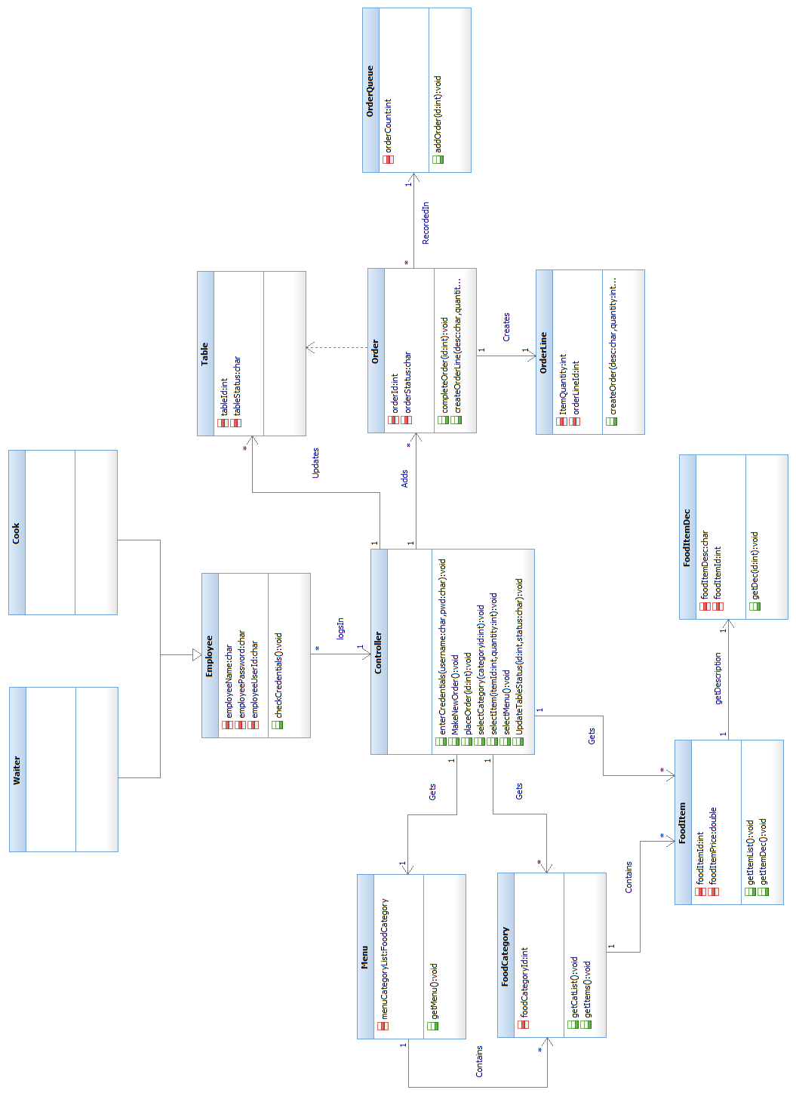
Design Class Diagram

9. High-Level Architecture Diagram
Version 4.0
11/19/14

Restaurant Automation System

Version | Date | Description | Author
3.0 | 11/10/2014 | Designed High-Level Architecture Diagram | Aneri Shah, Danny Sundaresan, Malika Pahva, Siddharth Shah, Vidhi Gavadia

Revision History

Logical View (Layers)
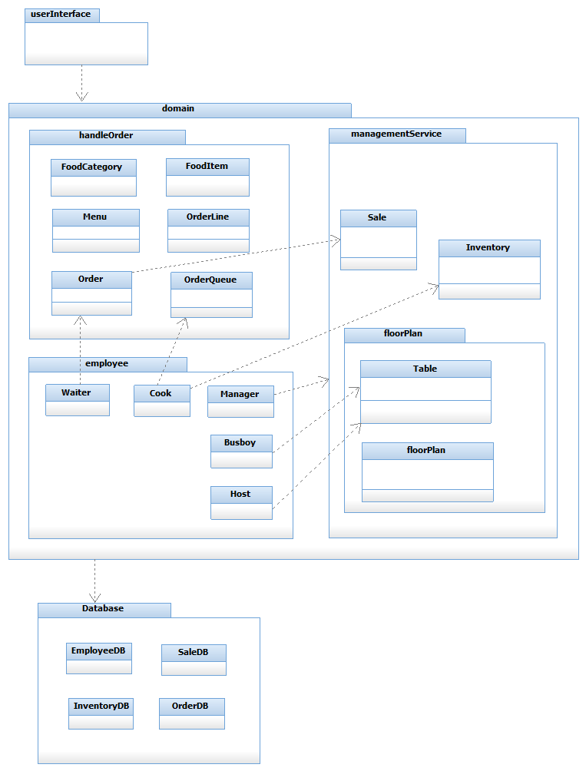

Logical View (Component Diagram)
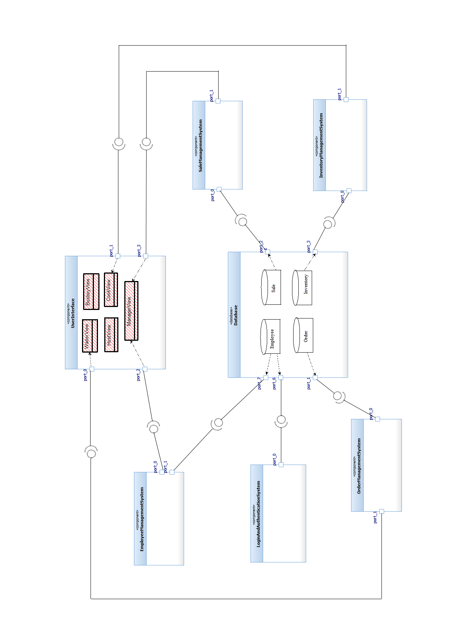

Deployment View
